Научный альманах (Физико-математические науки)
Kazmiruk I. Yu., Kirsanov M. N.
Adaptive algorithm for selecting the optimal route

To solve the problem of choosing the optimal route of a vessel usually involved the various methods of artificial intelligence, discrete mathematics and analysis. In many cases, the task is effectively solved by reduction to the problem of the shortest path in the graph. One of the most common for solving this problem methods is Dijkstra's algorithm [1,2]. This article analyses the influence of changes in environment on the choice of the path and its optimal length. The basis algorithm [3] developed in the computer mathematics system Maple [4]. The task is to find the optimal path among a given set of obstacles (Fig. 1). The initial (No. 8) and final (No. 16) route point are determined. The algorithm consists of two parts. First creates a complete graph of all routes with vertics at the end points of the segments. Then filtered out of the edges crossing the obstacles. Developed a routine in which the segment number k is represented in parametric form in two equations , , where the coordinates of the endpoints of the interval (the vertices of the graph), is the parameter. Similarly presented edges of complete graph: , , where The conditional operator the routine is implemented, which in the case of the solution of a system of four equations , when the conditions are met and (the segments intersect) excludes the edge from a complete graph. The subscripts in the subroutine k and j run through all numbers of line segments and edges of a complete graph. The corresponding fragment program has the form
> CrossTest:=proc(i1,i2,j1,j2) local
t1,t2,eq,X1,Y1,discr;
> discr:=(X[j2][1]-X[j1][1])*(X[i1][2]- X[i2][2])+(X[i1][1]-X[i2][1])*(X[j1][2]-X[j2][2]);
> if discr=0 then 1 else
> eq[1]:=X1=X[i1][1]*t1+(1-t1)*X[i2][1];
> eq[2]:=Y1=X[i1][2]*t1+(1-t1)*X[i2][2];
> eq[3]:=X1=X[j1][1]*t2+(1-t2)*X[j2][1];
> eq[4]:=Y1=X[j1][2]*t2+(1-t2)*X[j2][2];
> solve({seq(eq[i],i=1..4)},{X1,Y1,t1,t2}):
> assign(%):
> if (t1<1) and (t1>0) and (t2<1) and (t2>0)
then 0 else 1; fi;
> fi;
> end proc:

To the resulting graph we can apply the Dijkstra's algorithm, it is the second part of the algorithm. Figures 2 – 4 shows three variants of optimal routes for dierent values of the coordinates . Schedule changes the length of the path (Fig. 5) shows that the problem can result in the conditional steady-state mode, wherein changing the position of the vertex has little effect on the quantitative component of the result is reflected only in the configuration of the route.
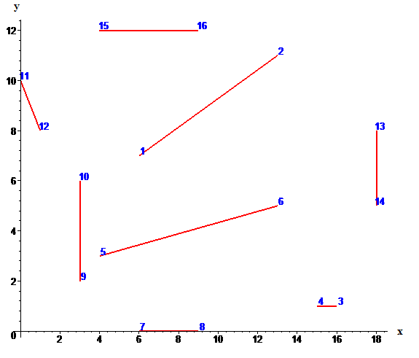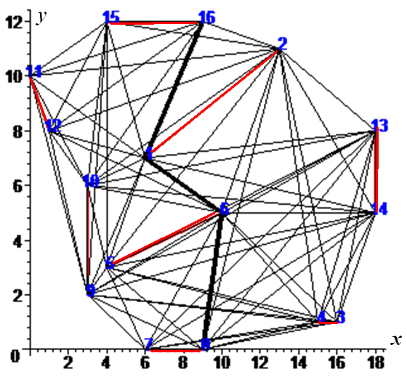
Fig. 1. Obstacles Fig. 2.
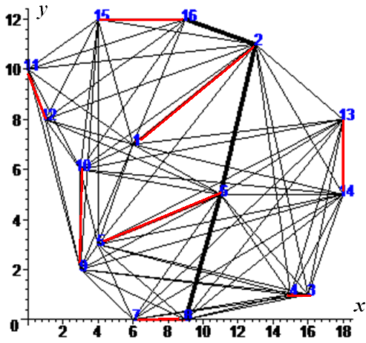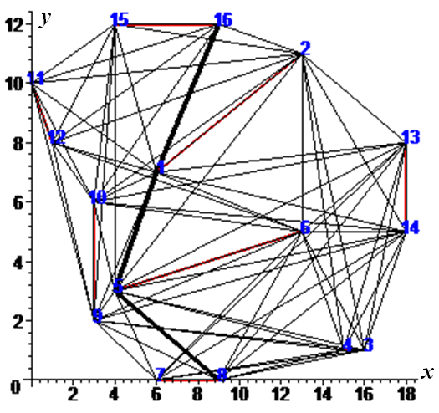
Fig. 3. Fig. 4.
Dijkstra's algorithm in Maple is implemented in the GraphTheory package and is invoked by the operator DijkstrasAlgorithm(Karta, PointBegin, PointEnd), where Karta is specified by the vertices and edges of the graph, PointBegin , PointEnd — the start and end points of the route. Let us build a chart based on the length of the optimal path from the abscissa of the point 6:
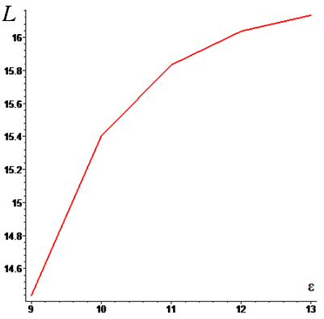
Fig. 5. The dependence of the length of the route from the coordinates of the point

To solve the problem of an optimal route are also used neural network approaches [5], ant algorithms and their modifications [6,7]. The more difficult problem of path selection arise in the analysis of group behavior of agents [8] and in problems with obstacles as polygons [9].
The work is executed at support of RFBR grant No. 16-01-00429.

List of sources used:
- Dijkstra E. W. A note on two problems in connexion with graphs// Numerische Mathematik. Vol. 1. Mathematisch Centrum, Amsterdam, The Netherlands. 1959. Pp. 269 – 271.
- Кирсанов М.Н. Графы в Maple. М.:ФИЗМАТЛИТ, 2007. 168 с.
- Кирсанов М.Н. Анализ алгоритмов выбора оптимальных маршрутов группы судов // Вестник государственного университета морского и речного флота им. адмирала С. О. Макарова. 2016. № 2 (36). С. 183 – 190.
- Кирсанов М. Н. Maple и Maplet. Решения задач механики. СПб.: Изд-во Лань, 2012. 512 с.
- Дерябин В.В. Алгоритмы обучения нейросетевой системы счисления пути судна // Вестник Государственного университета морского и речного флота имени адмирала С. О. Макарова. 2016. №3(37). С. 23–33.
- Курейчик В. М., Кажаров А.А. О некоторых модификациях муравьиного алгоритма // Известия Южного федерального университета. Технические науки. 2008. Т. 81. №. 4. С. 7–12.
- Kirsanov M.N., Shpitonkova E.A. Simulation of ant algorithm using maple with adding additional parameter// Системы компьютерной математики и их приложения. 2013. № 14. С. 62–64.
- Dedkov V.A., Kirsanov M.N. The problem of control for multirobot systems // Инновационные информационные технологии. 2013. № 2. С. 206.
- Kirsanov A., Anavatti S. G., Ray T. Path Planning for the Autonomous Underwater Vehicle // International Conference on Swarm, Evolutionary, and Memetic Computing. Springer International Publishing, 2013. Pp. 476 – 486.

